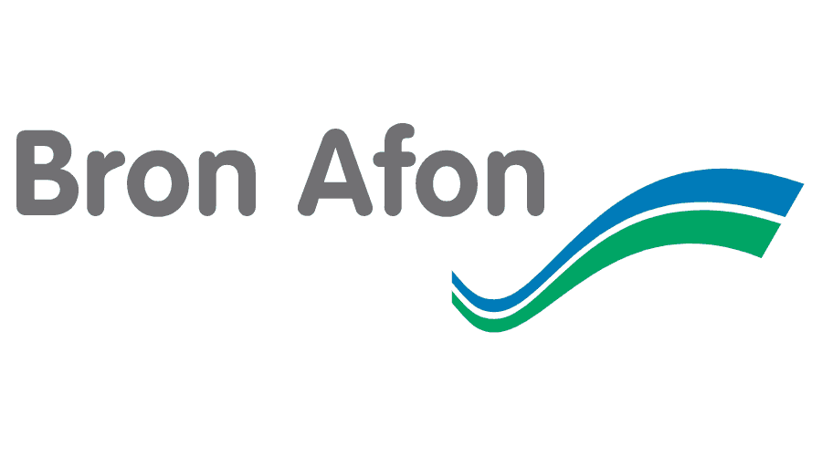
LEASEHOLD & SHARED OWNERSHIP ADMINISTRATION FEES 2023/24
As a leaseholder or shared owner of Bron Afon Community Housing Ltd. you may need to access information or seek permission from us. This document provides summary of the fees and charges associated with the work required to process and provide the information required. These are not included any annual service charge management fee and some maybe be subject to individual lease conditions.
This list below outlines the administration fees that are payable for the following services and includes VAT.

Item Amount
1 Sales Management Pack (LPE1) £264
2 Sales Additional Enquiries (Single enquiry) £24
(Multiple enquiries) £100
3 Sales Management Pack (LPE1) refresh (if less than 3 months) £120
4 Notice of Transfer Dependent on lease
5 Notice of Charge Dependent on lease
6 Re-mortgage enquiries £50
7 Consent to re-mortgage or transfer ownership (shared owners) £50
8 Consent for alterations (Non-structural) £100
(Structural) £150
9 Bron Afon Surveyor Fees (Non-Structural) £50
(Structural) £100
10 Lease extension (not inc. legal and valuation fees) £360
11 Deed of Variation (not inc. legal and any surveyor fees) £300
12 Copy lease £30
13 Enfranchisement Admin fee (per unit) £150

